Sort according to an Array.
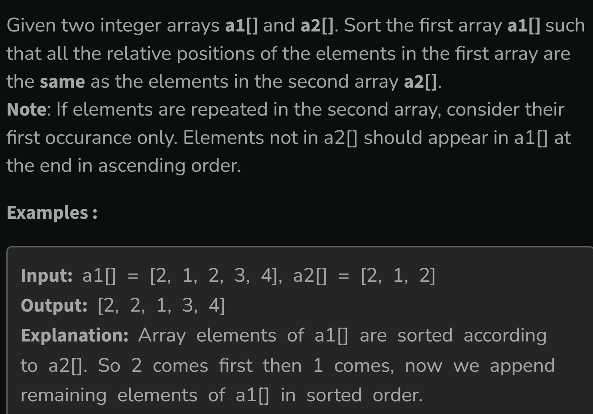
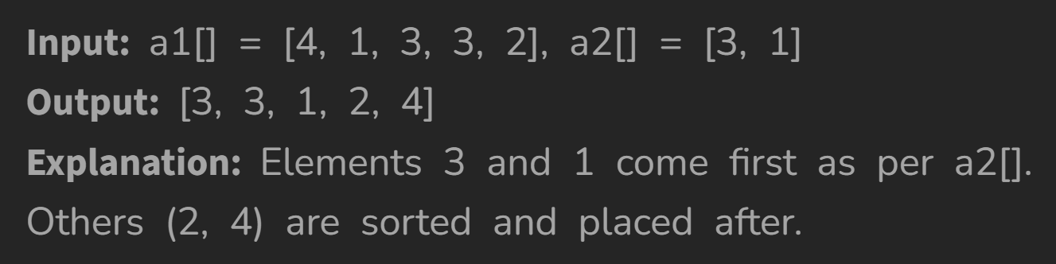
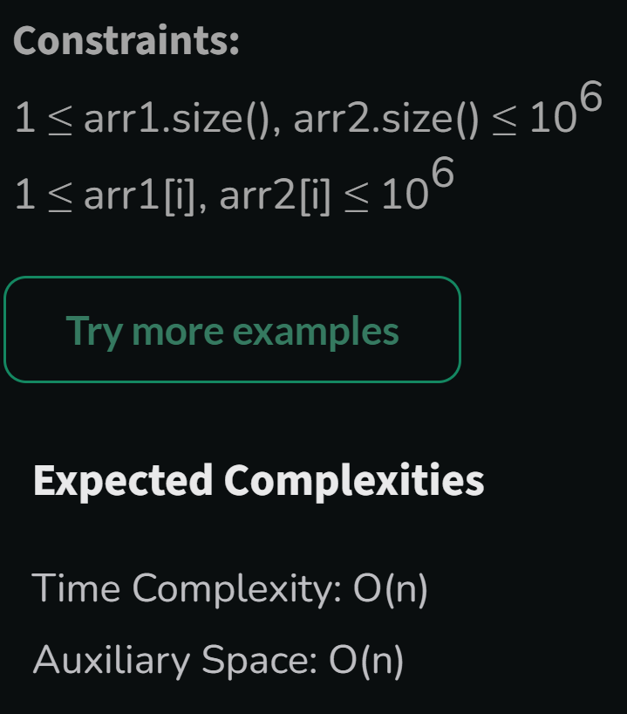
Solution working in the vscode but in the gfg it was not working.

